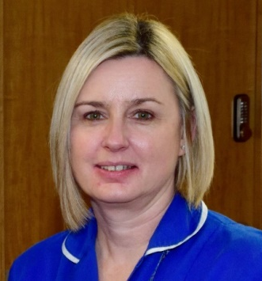
P
Case study
Name: Helen Payne
Job title: Cardiac Specialist Nurse

What role/ profession are you in?
I am a Cardiac Specialist Nurse. I always wanted to be a nurse and prior to taking up nursing as a career I was in the St John Ambulance and did some voluntary work in a hospital. I always felt I had the vocation to care for people.

I find the job very rewarding and with the level of expertise I have gained over the years I feel this is an excellent platform for me to advocate for my patients to ensure they receive the very best management of care. In the late 1980s the qualifications required for entry into nursing was just 5 GCSEs.
What did your early career look like?
Early nursing was very different to now. In my nurse training it was very much hands on, I learnt everything on the job. I was made to feel part of the team and had my own caseload of patients in the third year. On qualifying in 1992, I worked on a General Surgical ward at the Leicester General Hospital for 2 years before joining CCU (Cardiac Care Unit) in 1994. This was the start of my career in Cardiology. I progressed to Deputy Sister then Ward Sister before becoming a Cardiac Specialist Nurse and taking on extra qualifications - consultation and examination and non-medical prescribing modules.
How did you become a Cardiac Specialist Nurse?
I enjoyed school very much. I went straight from school and did a pre-nursing course for 1 year then into nursing early, aged 17½ years, so I have always been a nurse. I cannot imagine doing anything else.
What is a typical day as a Registered Nurse and Ward Manager?
Working as a Cardiac Specialist Nurse in the Rapid Access Chest Pain Clinic my typical day includes morning and afternoon clinics which are nurse led. I take the patients history, carry out a physical examination, and I then discuss the patient with the Cardiac Consultant for advice about further treatment management. I am able to prescribe medications, consent for coronary angiograms and facilitate further investigations. Health promotion and risk factors are discussed and the patient’s wellbeing always comes first. I also follow up my patients post coronary angiogram via a telephone call. I feel that the role is very rewarding and my skills set is perfect for the role.
Do you have any words of encouragement for anyone thinking about a career in health and social care?
Nursing is a very rewarding vocation. You can really make a difference in people’s lives. If you are of a caring nature and want to help people this is the job for you. It is hard work but very satisfying going home knowing you have done your best to care for your patients, making the patient journey as comfortable as possible by delivering the highest standard of care.

